Visit to The undergraduate training program in Family Medicine principles
in the Medical Faculty of Rwanda University .
Report by Fons Mathot and Pieter van den Hombergh
Date: 24- 2-2017 till 4-3-2017
We visited The University of Rwanda, (UR) Discipline of Primary Health Care for one week for both teaching and a brief evaluation of the teaching program, which is cofounded by the
PM-fund. Fons is chairman and Pieter vice-chairman of the Peter Manschot Fund (PM-fund). See LinkedIn profile:
The UR, Discipline of Primary Health Care has developed a strong undergraduate training program to introduce students to the principles of social and community medicine, Primary Health Care and Family Medicine competencies, which started in 2011. The SocoMed program (Social and Community Medicine) is a program for students in year 4 (theoretical) and consists of interactive lectures in FM-competencies (communication, palliative care , management, treatment of NCD, etc.) and year 5 (practical) which takes the students on field visits around Rwinkwavu.
The iSOCO training is is the further developed social and community medicine training in the new curriculum (which started in 2014) for medical students in year 1-2-3-4 (including dental students in year 1-2 and pharmacy students in year 1) and which replaced SocoMed for the new generation of students. This training strongly uses the model of the “desired Rwandan Medical doctor” who is a patient-centred and community-oriented care provider who has the competencies of being a communicator, collaborator, health advocate, manager, scholar and professional (using the CanMeds 2003 framework). The training is built on five fields: population health, social medicine, health systems, communication and professionalism. The iSOCO training year 1-2-3 is theoretical and takes place in Butare, year 4 will be practical. This training was implemented in 2014 and is still under development.
The teaching that Pieter and Fons joined, concerned 400 third to fifth year students, 200 (SocoMed year 4) in Kigali and 200 (iSOCO year 3) in Butare. The students in Kigali were in their fourth year, and received a 2 week lecturing program concluded with an exam. For the 4th years students is was their first encounter with SocoMed. In Kigali we also joined a group of 10 fifth year students during their visit to the palliative care unit in Kibagabaga hospital during their 5th year SocoMed training.
In Butare the 200 students were 3rd year students of the new curriculum and for them this was the 3rd year to receive training in iSOCO. For a quick view of the online program which is used for this training::
- go to http://cmhs.tulanerw.org/ click on School of Medicine and Pharmacy
- choose between 2017 Social and Community Medicine year 3, or Social and Community Medicine year 2, or 2017 Social and Community Medicine year 1.
- At the Log in , go to the bottom, there is a green column which says "Log in as a guest"
- Welcome: you can look through the program and see what the students see.
The 3rd year iSOCO training was a 2-week training which was provided for the first time this year as a continuation of the year 1 and 2 training for the new curriculum medical students. On the final day of this training we attended the mesmerising lecture of Phil Cotton, who is vice chancellor of the UR and the only faculty in in the Discipline of PHC.
Visits and discussions involved:
- Honorary Associate Prof. Mieke Visser, Dutch FP, team leader and HoD of FM-dep.,
- Dr. Mariette de Reeper, Dutch FP and teacher in the medical undergraduate training program,
- Honorary Associate Prof. Maaike Flinkenflögel, former HoD & visiting assistant team leader
- Dr. Alfred Rutagengwa, Rwandan FM physician, graduated in 2012
- Dr. Musafiri Rogers, Rwandan FM physician, graduated in 2012
- Dr. Theoneste Rubanzabigwi, Rwandan FM physician, graduated in 2012 (future President of the Association of Rwandan FPs)
- Dr. Stephen Merjavy (FP, Atlanta, US)
- Dr. Namatovu Jane Frances (HoD FM Makerere University),
- Dr. Katie Cartedge (FP, UK)
- Dr. Richard Nduwayezu (Intern Doctor at Kibagabaga Hospital), assistant teacher in the iSOCO program
- Dr. Jan Borg, Family Practitioner , now consultant for the Belgian budget finance program.
- Dr. Pierre Dongier FP and consultant for MoH and HIV-programs.
- Dr. Florence Akiki Director for DMET (Department of Medical Education and Training) at PIH (Partners in Health)
- Harris Lagisdakis, PhD student , Aarhus University (in collaboration with Vincent Cubaka)
- Many students
Rationale
Fons and Pieter both were offered the opportunity to teach 3 x 2 hours on Palliative care and Management respectively to students both in Kigali (year 4 SocoMed program) and Butare (year 3 iSOCO program). This is their report and they also used this visit to do some evaluation of the Socomed program on behalf of the PM-fund. For this they spoke with experts and stakeholders on the perspective of FM-training in Rwanda. There was no demand for a rigorous evaluation.
Yet, on behalf of the PM-fund, which funded the Technical Assistance (teachers & organisation costs) as well as the organisation of SocoMed and on behalf of the Dutch support group of FM-training, they collected information on the program. They discussed how to proceed with the program, after the departure of Maaike and the impending suspension of the position of Mieke at PIH. PIH intends to continue the SocoMed Field program after this year for 100 students, but not to increase the number based on the amounts of students which will actually need to follow this training in the future. That would require hosting 200 SocoMed and 200 ISOCO students in the academic year 2017-28 and that is very problematic.
Family Medicine in Rwanda - Background
in 2012 nine Family Practitioners graduated from the new 4-year FM-Master program that was started in 2008. They were allowed to graduate as specialists in FM on a par with other specialists. The program was suspended by the previous minister of health, because of financial and other constraints, like giving preference to specialist training.
The Dutch participation was redirected at the undergraduate training and Socomed was started in 2011 with support of Tulane University and Partners in Health (PIH). The program involved teaching in the 4th year and added field visits in the 5th year coordinated in (PIH). The good evaluations of the Socomed program by the students and the university was undisputable high and everybody agreed unanimously that it should be continued.
After the start of the undergraduate program in 2011 by Prof. Cal Wilson (University of Colorado), Maaike helped to further set up the curriculum , who was appointed as Head of Department (HoD) of the Discipline of Primary Health Care (first 50%, later 100%) . She supported him from afar with the 5th year training which started in Kabgayi district hospital (Gitarama) and later Rinkwavu. Mieke had a 0% appointment as honorary associate professor in FM at the UR) and a 50% (later 30%) salaried position at PIH for the postgraduate FAMCO (family and community medicine) and later when the year 5 SocoMed program came to Rwinkwavu she got involved in the further development of this undergraduate program. The department has always run on the support of volunteer doctors and family physicians from abroad. In the 2016-17 academic year Mariette de Reeper will help out as a Family Practitioner with long experience for six weeks in the program.
Mieke took over the coordination of the year 4 SocoMed program in 2015, together with support from the PM fund and she has worked with Dutch volunteer family medicine physicians to run this program smoothly (in 2015 Marga Vintges joined and in 2016 Marianne Holtland joined for this 2 week training).
Jane Namatovu who is the HoD Family Medicine at Makarere University, Uganda, has been supporting the 4th year SocoMed training for the second year in a row with support of a grant from the IUCEA (Inter University Council East Africa) .
Mieke is presently acting HoD with 0% position (in conjunction with Vincent Cubaka). There is no finance for a HoD from the UR. . Funding is seriously needed to strengthen the sustainability of the undergraduate program and to advocate for the ending of the suspension of the postgraduate FM-training. The University supported two recently graduated medical doctors who are now in their intern year to work with the undergraduate iSOCO program for the coming months. Dr. Richard Nduwayezu and Dr. Magnifique Irakoze are two committed physicians who have been actively involved in social and community medicine in and next to their medical training. They will now be teaching assistants in the program.
Mieke is managing the 4th year program by involving Mariette, Jane, Richard and Magnifique as teaching assistants and several other teachers. The 3rd year program was developed and run by Maaike and year 1 and 2 was developed in the previous years and will be run by Mieke, Mariette, Richard and Magnifique in the coming months. Much is done on a voluntary basis with only some compensation for travel and living. That is an accomplishment. With regular payments of even local staff the program would have costed a multitude of the costs now. The total costs are hard to estimate because normally hosting the students, payment of the department etc. are running costs. The contribution of the PM-fund was: € 4940,= . (for per diem and travel). PIH funded the 5th year program in Rwinkwavu with Eleazar and Mieke as the main staff. This year Fons Pieter and Mariette paid most of their travel costs and lodging themselves. So a clear financial picture is difficult.
Impressions
Our visit started with a meeting with all FM physicians involved in moving forward the FM-approach in health care. (see APPENDIX I) For me it was encouraging to see Family Practitioners, who all were very successful in positions like hospital director, UNAID-consultant and Medical director of Mission hospitals. We first met in 2012 when the first nine FM-trainee were in the 2 day management course, that I gave. It was good to see them doing so well. Almost all still were clinically active and were committed to be doing so.
We discussed strategic suggestions for an approach of the new minister to lift the ban on the training. The draft letter would be shared with everybody and Theoneste would present it on behalf of the future association of Family Practitioners. The participants acknowledged that the MoH has different priorities and has accomplished great progress in quality of the health care.
The challenge is to make clear to the MoH how FM can contribute in solving actual problems, like boosting the PHC through providing leadership and motivation of staff through trained FPs. This ambition should be seen against the huge problems of dried up funding and scarce resources. Yet restarting FM-training may well rekindle donor enthusiasm to support this with the ultimate goal of realising universal coverage.
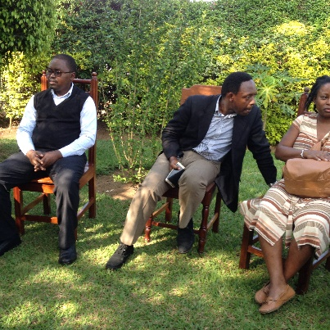 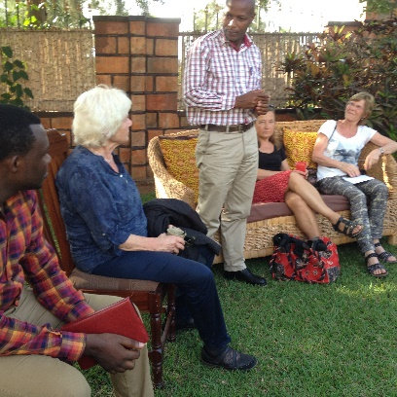 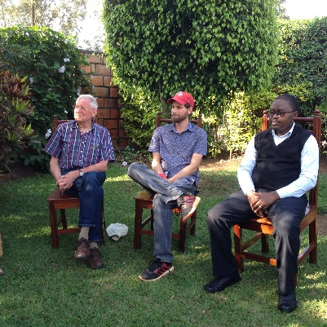
Rogers, Alfred Richard, Mieke, Theoneste, Eva, Mariette Fons, Steven, Rogers
Monday to Thursday was teaching for the Socomed program and presentations by the students that they evaluated themselves. Teaching was Communication * Family Medicine (Jane, Katie, Mariette), Palliative care (Fons), Management (Pieter), Empathy (Phillip).
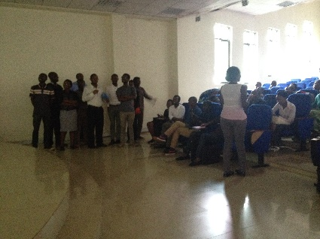 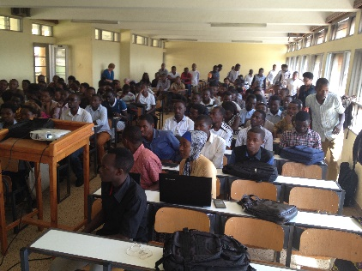
Presentation by year 4 students Lecture in Butare, year 3, 200 students
In the evening we had dinner and spoke to Jan Borg, who supervised the budget financing to the MoH (12 million Euro) from the BTC (Belgian Technical Cooperation). He approved the enormous accomplishments of the MoH but acknowledged the high donor dependence. The medical education which is rather expensive and also highly dependent on (dwindling) donor money. That leaves little room for investing in new training programs. The community nurse program is a success, but though highly motivated, are not being paid (except for some PBF-funding). This is a possible weakness. Jan Borg also mentioned the gap between hospitals and the level of the health centres. Especially the NCD should be primary care but are now often handled in the hospitals. Lack of an academic, supervising generalist was felt. We shared the possibilities to increase awareness in the MoH of promises of FM-principles introduction in PHC. This is the strategy of the WHO and why would Rwanda be different. We spoke about the evaluation of CHW’s and the Community Performance-Based Financing program (CPBF) and CHWs cooperatives. It would greatly improve the service of care in the 480 health centres, when FM-principles could be introduced. Supervision & motivation could do with physicians being trained in FM to these competencies..
Next night (Tuesday) we spoke with Pierre Dongier, who confirmed the looming difficulties in financing. He was quite positive and suggested an approach to help the new minister to solve her problems with motivating the present Primary Health Care-level. He said it was good to have patience with the appointment with the minister. It would take time. It helped to have realistic expectations on the change in strategy of the MoH to FM-orientation.
With Jan and Pierre we discussed all the arguments of why FM approach, that could make a difference, but it is all important that these arguments will be heard and shared with the MOH.
Thursday we had dinner with Akiki of PIH and she confirmed that Alex (PIH country director) would restructure the field program. They consider cutting on the high salary costs of Mieke.
On Thursday morning we travelled to Butare to provide the training for the 3rd year students. That evening we had dinner with Maaike and Mariette. Friday were the exams for the 3rd year students finishing their two week training. After this we listened to a mesmerising lecture of Phil Cotton as the closing session. We met briefly with him over lunch and agreed to continue our discussion on skype.
Harris Lygidakis is working on his PhD project in Rwanda, together with Vincent Cubaka, one of the Rwandan trained family physicians who is enrolled at the University of Aarhus, in collaboration with the University of Rwanda and the Rwanda Biomedical Center. I spoke to him on Skype and we explored the possibility of bringing more European countries together, when applying for a European grant, if that would be a demand.
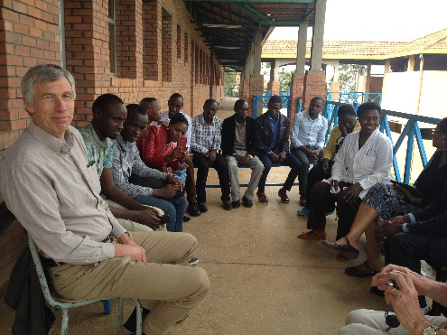 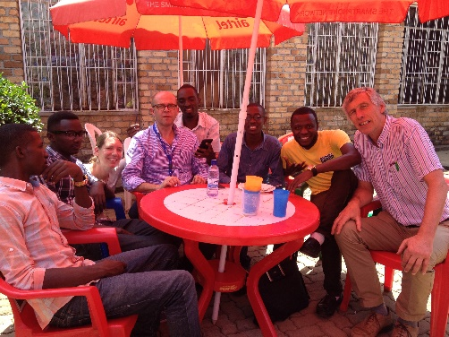
Palliative care lecture, Kibagabaga hospital (yr 5) Students, Phil Cotton & Pieter, lunch Butare
Conclusion
The overwhelming approval by the students of the undergraduate training programs of SocoMed and iSOCO (Word spread that it was the best program in the curriculum) and the commitment of all participating teachers can be seen as proof of its relevance in the medical education. All prayed for it to be continued.
It was also clear to all of us that the students of the new curriculum, who had been participating in the iSOCO program in their first and second year, were more responsive and knowledgeable about the use of FM principles in health care as the 4th year students in Kigali , who just entered this SocoMed program. This is circumstantial proof that the skills and knowledge of the FM-approach were rapidly picked up and appreciated by these students.
We left with the feeling that this undergraduate program – next to the restart of the postgraduate FM-training- is very valuable. Students were clearly disappointed to learn that possibilities for further training in FM are not there.
That disappointment came from a genuine feeling that as a Family Medicine Physician they could make a difference. Many hope that the iSOCO program will continue and one of the hopes is Vincent Cubaka who will finalise his PhD this academic year and will return to Rwanda. When funds are available and otherwise feasible he could become the new HoD who will continue the undergraduate iSOCO training, strengthen research in this field and can be supporting revitalising the postgraduate program. For these undergraduate years all teaching material is available on the online Moodle platform, but teachers are insufficient. Another hope is that the UR will support the two teaching assistants, Richard and Magnifique to become faculty. The iSOCO program needs the field/ community experience in year 4 and without teaching staff is insufficient and not sustainable.
Short term actions
1. Theoneste, Richard and other members of the future association of Family Practitioners together with representatives of the FM-training (Mieke as team leader and HoD ad interim) will prepare a letter asking for an open discussion on how boosting FM could help to solve future development of the system in universal coverage, better service and relevant, cost-effective, integrated care.
2. Pieter invited Phil for a Skype meeting together with Maaike. Mieke and Fons are also possible attendants. The meeting should be on Phil’s opinion on how the future of FM could be revitalised in Rwanda and save guarded.
Long term action.
The MoH should ideally see the FM-approach as a solution and not a problem. We all hope the MoH is willing to change her strategy towards more support for introducing FM-principles in their PHC-system and to investing FM-training. The Rwandan people may benefit from more personal care. The association with the MoH could jointly look for ways to get support for effective strategies to make this renewed FM-approach possible.
On the short run it means for iSOCO to become a sustainable and essential part of the undergraduate medical education. For that it may need further support (PIH?) besides the current regular support by the university. It is clear that continuation of the iSOCO program would only happen with a head of dep. of FM. The position is there and MoH and UR may agree on reinforcing it.
For the FM-training (Master) the MoH may ask for a strong convincing business case.
The MoH may see perspective in the short run of having a substantial number of Family Medicine Physicians to boost service and quality at the smaller hospital and health centre level. The MoH may object to the fact that it requires an investment of 4 years before they have these Physicians.
Yet, the MoH may like the perspective that FM-trainees in hospitals (as was shown in Kenya) prove to be of immediate value for the service and outcome in rural hospitals.
Compulsory service years could be rewarded with FM-training in those years making regular physicians more motivated during this period to do this service with a valuable future goal.
Programs with such perspective are relatively cheap and are likely to attract funding, although this is less obvious with the present drop in funds. Restarting the FM-training would create enthusiasm and job perspective to the many Physicians who now work as GPs. Training generates great motivation. Experience abroad suggests that training hospitals improve greatly on service, comprehensive care and commitment. For the MoH to tap in on such benefits of training may help to reconsider investing in FM-training. We think it is feasible to restart the Masters training in FM and have a first year with a considerable cohort of physicians, who do their compulsory service. This could be cost-effective, given the return on investment of qualified Family Medicine Physicians. See also the paper: https://www.researchgate.net/publication/299490364_Providing_proper_generalist_care_during_compulsary_service_as_Medical_Officer
Training offered during that 1st year would motivate students and at the end of year 1 students could be elected for further specialisation (also other specialties. Training hospitals improve greatly on integrated care and service. This could be done at minimal costs with maximum gain for the MoH and the Rwandan people. Projects could ask for donor funding, that have a chance of being granted.
The Dep. of FM in collaboration with The association of FM could host these projects. Parallel to this the training would facilitate the other staff of PHC-units to be introduced into the principles of the Family Medicine approach.
This is only one direction for solving some of the problems. We hope that all stakeholders will come up with improved plans, that may be met with enthusiasm by the MoH and the minister.
Way forward
This report will be presented to the PM-fund on 9-6-2017.
Acknowledgements
We greatly thank all of the mentioned people for their hospitality and cooperation. We enjoyed this.
-----------------------------------------------------------------------------------------------------------------------------
APPENDIX 1
The Future of Family Medicine in Rwanda- Meeting minutes
Venue: Katie Cartledge and Peter’s House at KIMIHURURA
Date: Sunday the 26th February 2017
Time: 3pm to 6pm
On Agenda:
1) Future of the discipline of Primary Health Care at the University of Rwanda.
2) Foundation of a Medical Association of Family Medicine physician.
Chairperson: Dr. Mieke Visser
The meeting started by self-introduction of the participants and welcomed Dr. Fons Mathot and Pieter Van den Hombergh from the Netherlands who joined us for this important cause. The meeting gathered together Family Physician from Rwanda Dr. Alfred Rutagengwa, Dr. Musafiri Rogers, Dr. Theoneste Rubanzabigwi (also the President of the Association of Rwandan Family Physicians), Dr. Stephen Merjavy (family physician from the USA), Dr. Namatovu Jane Frances (HoD Family Medicine at Makerere University), Dr. Marriette de Reeper (Family physician from the Netherlands), Dr. Katie Cartedge (Family Physician from the UK) and Dr. Richard Nduwayezu (Intern Doctor at Kibagabaga Hospital).
Dr. Mieke started by giving us the update about the social and community medicine training of medical students and explained the challenges that we have, which includes:
- Currently there is no head of department of Social and Community Medicine at the University of Rwanda since Dr Maaike has left
- There are not enough faculty members to teach the medical students at the military camp in Nyamata which means the faculty members have to teach in the Huye campus as well as in Nyamata
- Sustainability of the social and community medicine training of DOC3 students because the University of Rwanda is not funding this program, it is Partners in Health alone financing it. This is a problem for the ownership of the program
The future of the Family Medicine program
The program was ended without clear guidance or documentation. If there have been any documents made detailing the ending of the program, either at the Ministry of Health or the University of Rwanda, these need to be found.
The new Ministry of Health have to be approached to discuss a new family medicine program. There is a concept note that has to be revised and this should be presented to the MoH. The President and his team at the Association of Rwandan Family Physicians has to go with an academic from the University of Rwanda to facilitate this. The Vice-Chancellor of UR, Professor Cotton, should be contacted to see if he can do this.
In the concept note, it should be clear that the program will focus on primary healthcare but the name should be harmonized with the region in terms of calling it Family Medicine.
The issue of ownership and funding of the program remains. Either it will be funded by the MoH or the University of Rwanda, or a collaboration of the two. The collaboration between the two bodies will need to be negotiated and discussed.
Opportunities available:
- Written concept note
- Students who want to join the program
- Potential support and human resources to support the program (Dr Vincent Cubaka could act as the Head of Department of the program)
- External funding and collaboration
What is needed:
- MoH needs to give approval to restart the program
- The University of Rwanda has to show commitment and support and appoint a head of department
- Rwandan advocators need to schedule the appointment with the MoH and explain and show opportunities that are available to start the program once again
- Scheduling tasks given to Dr Theoneste
Minutes elaborated by Richard Nduwayezu

https://www.linkedin.com/in/pieter-van-den-hombergh-95882018/
https://www.linkedin.com/in/fons-mathot-65a46716/
Flinkenflögel M, Cubaka VK, Schriver M, Kyamanywa P, Muhumuza I, Kallestrup P, Cotton P. The Desired Rwandan Health Care Provider: Development and delivery of undergraduate social and community medicine training. Educ Prim Care. 2015. 26(5)343-348. http://dx.doi.org/10.1080/14739879.2015.1079969
Flinkenflögel M, Kyamanywa P, Cubaka VK, Cotton P. The next generation of Rwandan Physicians with a Primary Health Care mindset. African Journal of Primary Health Care and Family Medicine. 2015. 7(1) http://doi:10.4102/phcfm.v7i1.885
Cubaka VK, Kyamanywa P, Flinkenflögel M, Schriver M, Ngabire E, Cotton P. Transforming health professional education in Rwanda – Contributions from Social and Community Medicine. Rwandan Journal for Medicine and Health Sciences. 2015. 2(1)93-95 www.ajol.info/index.php/rj/issue/view/1288

